1. Data Model
Table | Description
olist_customers_dataset | Stores customer details and location info (zip code, city, state).
olist_orders_dataset | Stores core order flow, status, purchase and delivery timestamps.
olist_order_items_dataset | Stores items purchased within each order, seller ID, price, and freight.
olist_order_payments_dataset | Stores order payment details (payment type, installments, payment value).
olist_order_reviews_dataset | Stores customer review ratings and review comments for completed orders.
olist_products_dataset | Stores product attributes (category name, dimensions, weight, photo counts).
olist_sellers_dataset | Stores seller details and seller location info (zip code, city, state).
olist_geolocation_dataset | Stores Brazilian geographic coordinates (zip code prefix, latitude, longitude).
product_category_name_translation | Translates product category names from Portuguese to English.

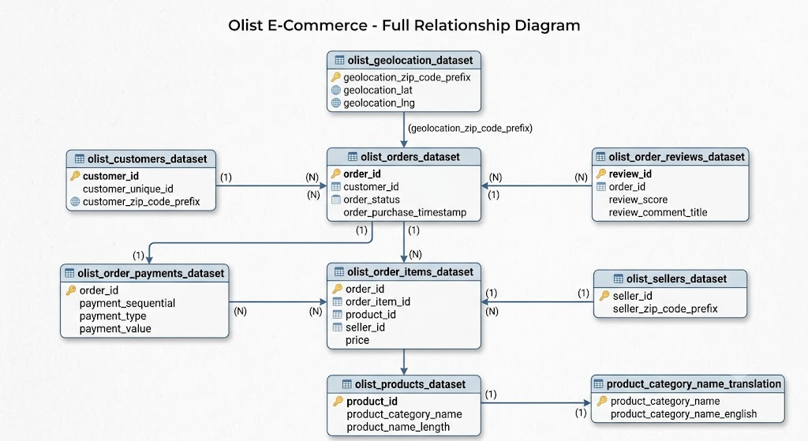

2. Metrics Definition
Metrics | Formula | Business Purpose
Revenue | SUM(payment_value) | Measure total sales revenue
Orders | COUNT(order_item_id) | Measure transaction volume
Average Order Value | Revenue / Orders | Measure customer purchasing behavior
Top Products | Total Sales by Product | Identify best-selling products
Monthly Revenue | Revenue grouped by Month | Monitor business growth over time
Sales by Category | Revenue grouped by Product Category | Compare sales performance across product categories

3. SQL Analysis

Revenue
Purpose: Calculate the total revenue generated from all completed customer payments.
SQL:  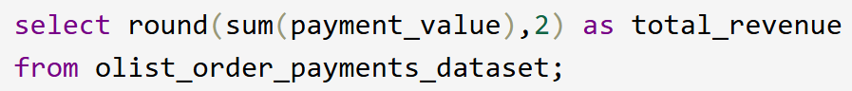 | Result:  $48,026,616.36
Business Interpretation: Total revenue represents the overall sales performance and serves as the primary indicator of business growth.

Orders
Purpose: Calculate the total number of completed orders.
SQL:  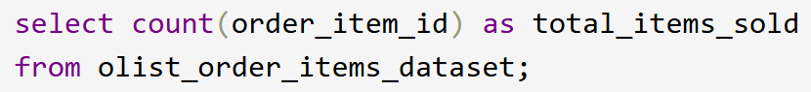 | Result:  337,950
Business Interpretation: The total number of completed orders reflects overall transaction volume and customer purchasing activity.

Average Order Value
Purpose: Calculate the average revenue generated per completed order.
SQL:  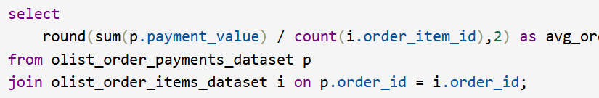 | Result:  172.69
Business Interpretation: Average Order Value helps evaluate customer purchasing behavior and overall spending patterns.

Top Products
Purpose: Identify the highest-performing products based on total sales revenue.
SQL:  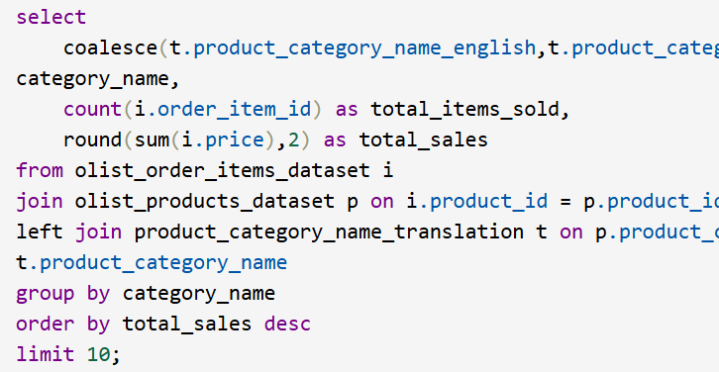 | Result:  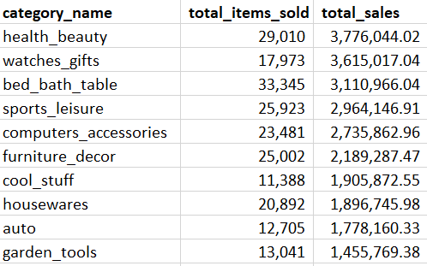
Business Interpretation: Top-selling products highlight customer preferences and support inventory planning and merchandising decisions.

Monthly Revenue
Purpose: Analyze monthly revenue trends over time.
SQL:  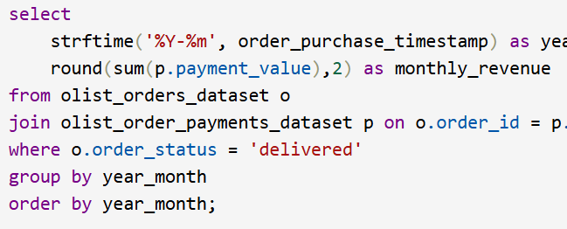 | Result:  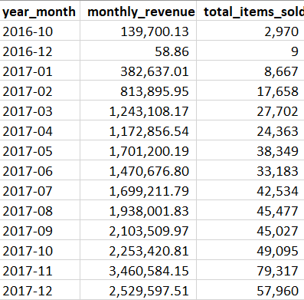
Business Interpretation: Monthly revenue trends help identify seasonality, business growth, and potential sales fluctuations.

Sales by Category
Purpose: Compare sales performance across different product categories.
SQL:   | Result:  
Business Interpretation: Category-level sales analysis helps identify high-performing product categories and supports strategic business planning.

4. Business Insights
- Monthly revenue shows a stable upward trend, indicating consistent business growth.
- A small number of products contribute a significant portion of total sales revenue, suggesting opportunities for inventory optimization and targeted marketing.
- Certain product categories consistently generate higher revenue than others and should remain strategic business priorities.
- Average order value remains relatively stable, indicating consistent customer purchasing behavior.
- The analytics dashboard enables business managers to monitor business performance in real time instead of relying on manually prepared reports, improving decision-making efficiency.

5. Recommendations
Recommendation | Business Value
Promote top-selling products | Increase Revenue
Focus marketing on high-performing categories | Improve campaign effectiveness
Monitor monthly revenue trends | Detect seasonal opportunities
Expand dashboard with customer segmentation | Improve customer insights

